The powerpoint presentation should address the following:

- Who is César Chávez?
Cesar Chavez was an American civil rights activist and a labor leader who with the help of Dolores Huerta founded the National Farm Workers Association which was later on renamed the United Farm Workers union in 1962. Chavez was a Mexican American farm worker who fought for civil rights and was hence promoted by the American labor movement.
2. What do you find most fascinating about César Chávez?
I find the fact that Cesar Chavez was originally Mexican and still fought for the rights of workers in American soil fascinating. He was also promoted by the American Labor Movement since they wanted to include people within its organization who were not originally from the States.
3. Identify 3 key events that highlight the goals of the original March.
- Acknowledgement of diversity in cultures.
- Display of value.
- Mexicans wanted to be allowed to enter the US and search for their livelihood.
- Did you know about the march previously?
Yes, I did. I came across the march as I was going through the internet. The site was rich in information concerning the history of the Mexican American in the past. I developed an interest in learning more concerning the history of the Latinos. I think they are part of this great nation and we should agree in one accord that there is a need to have a diverse culture.
5. Why is it important to study the march? What impacts did it have at the time, and what lessons can we gather from this time period?
It made the Americans appreciate diversity in cultures.
It brought the attention of the evil things that were done to the Latinos. Both verbal and physical abuse had to stop.
One of the lessons that can be gathered from this time period is that all people should be equally treated regardless of race, and ethnicity differences among others.
Secondly, the rights of all people should be guarded.
6. Why is it important then that we have a march on campus for migrant workers? Do you think most Americans today are aware of this social issue?
It is important that we have a march on campus for migrant workers because they support the state's economy, and they enrich our culture among others.
To some extent, it can be claimed that some of the Americans today are aware of this social issue because they have appeared to differ on the same issue. There are some who have acknowledged the need to have a diverse culture within the country. On the other hand, we have all witnessed the current President; Trump wanted to depot most of the immigrants. Also, he wants so much to build a Wall that separates the US and Mexico which is a clear indication that he does not like cultural diversity.
7. After addressing the previously mentioned questions, be sure to provide your professor with photos of your final project. You MUST include photos of your progress and the materials that you used to make the project. Please keep in mind that this is for a march. As such, do not make a project that is too large to be used come the day of the rally.
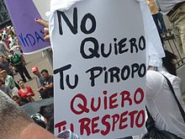
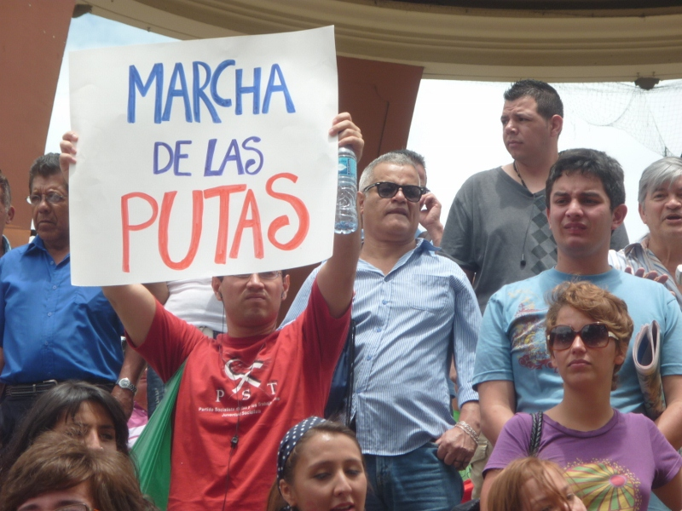

8. On the last slide of the powerpoint, indicate whether you are willing to allow your powerpoint presentation to be shared on the department's website.
9. Also, be prepared to give a presentation in class (for face to face students only).

